Sample memory access 1

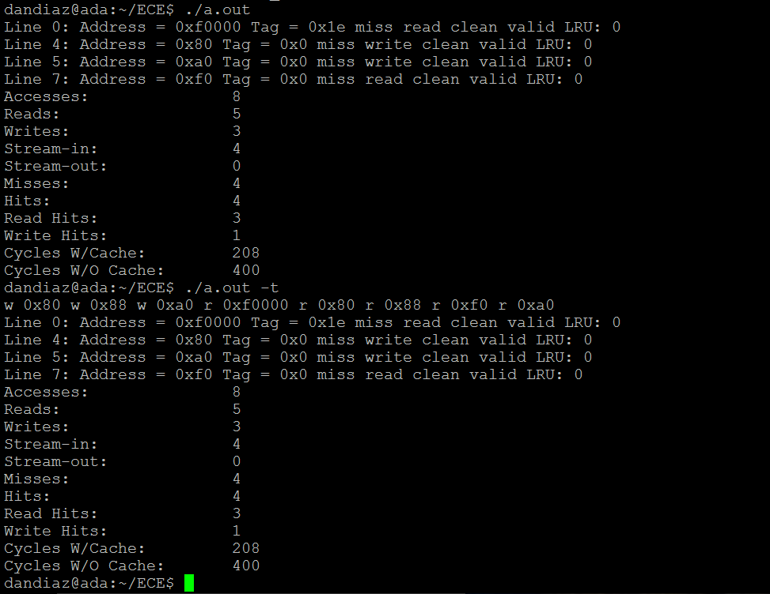

Sample memory access 2

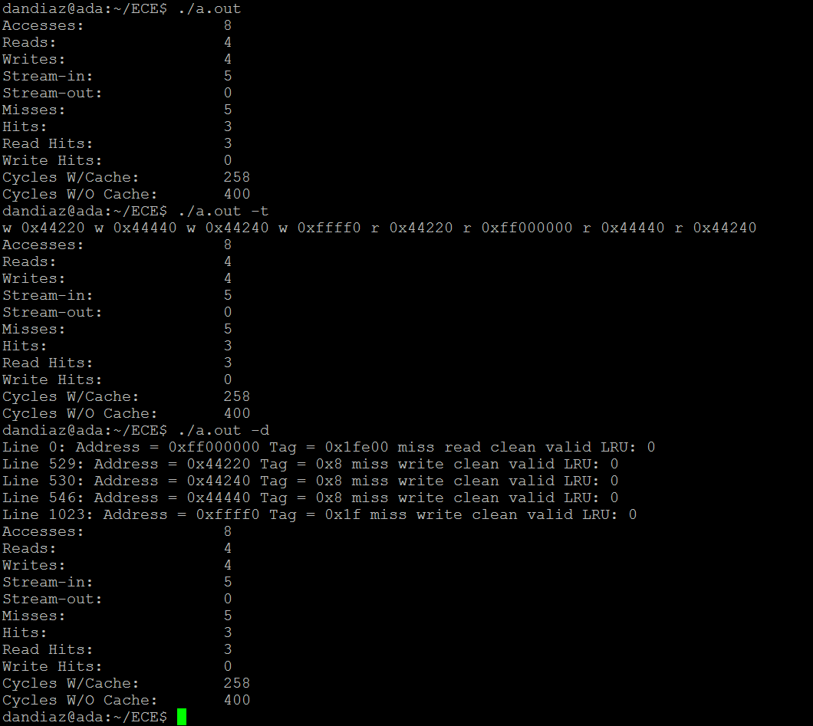

Sample memory access 3

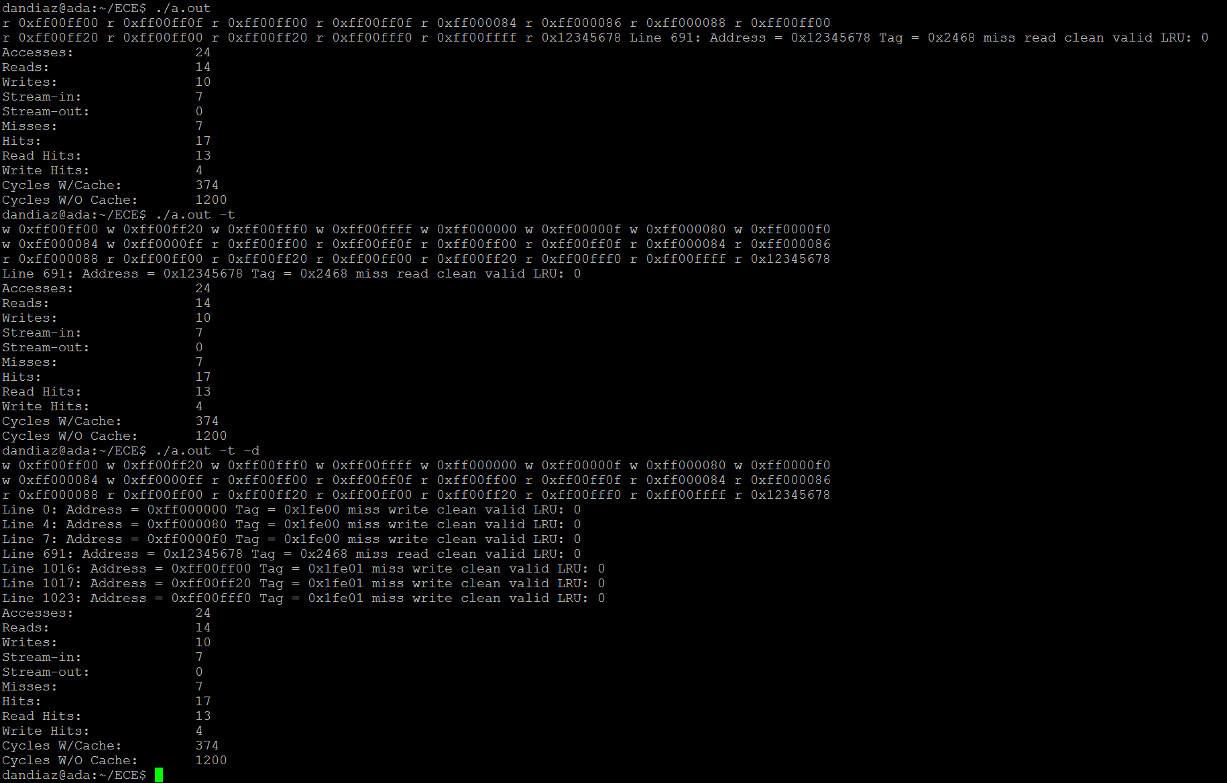

Running simulator using homework 1:

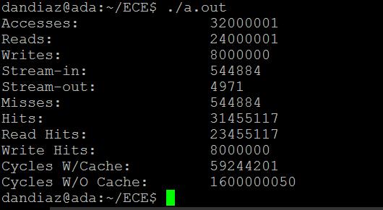

Running simulator using homework 1 and -d debug flag at the beginning causes a seg fault because we require too much memory. The following has a -d debug flag 100 lines before the end of the file:

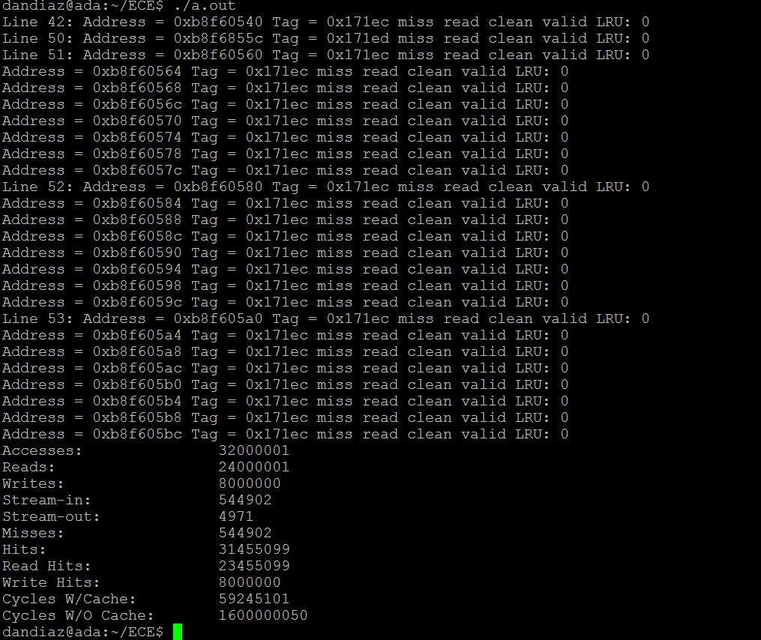

Smaller 100 X 100 matrix multiple address generation output:

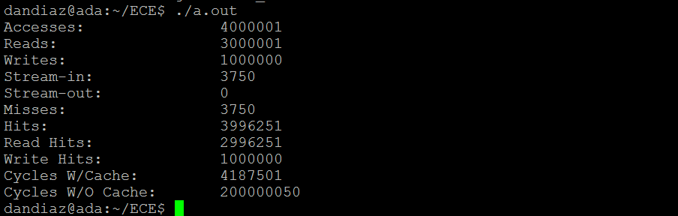

A dump (-d) using the same size matrix:

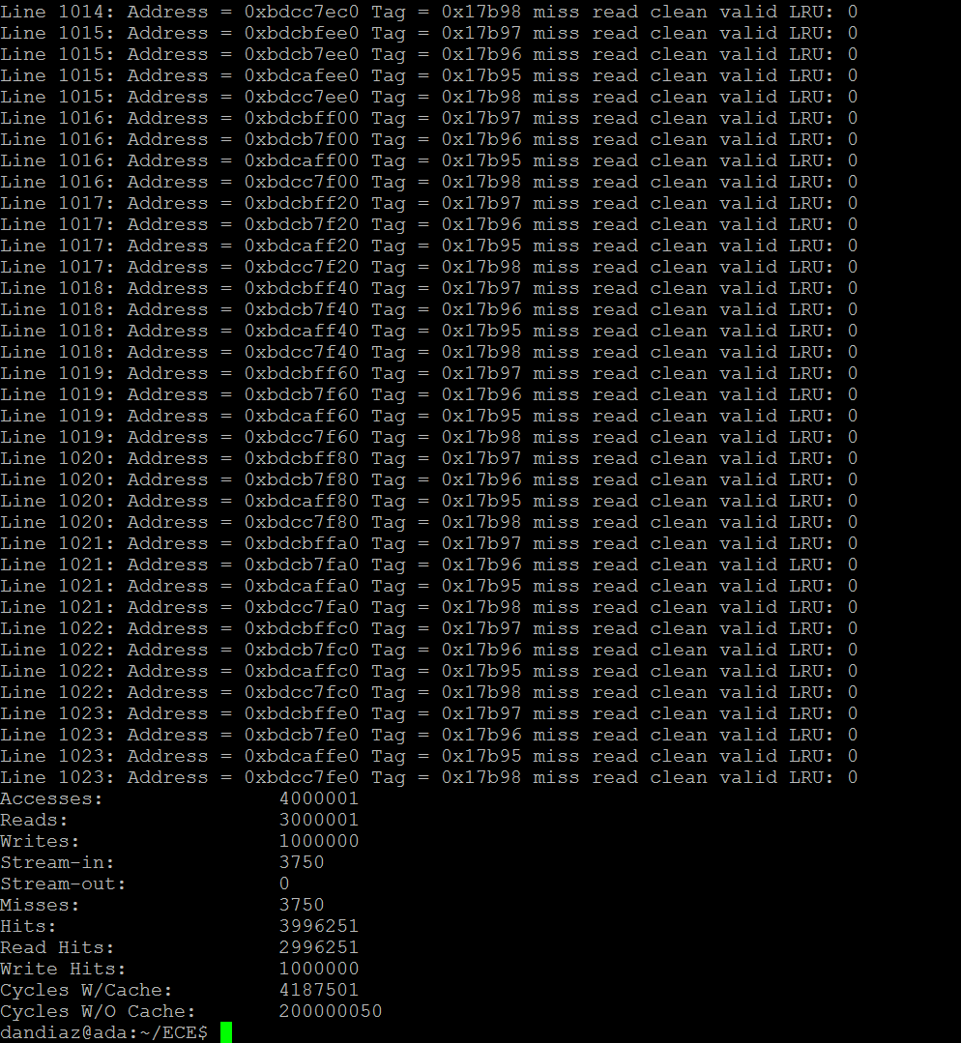

Same trace but with added -d -t and -v flags 300 lines before the end of the file:

